Knitted daffodil
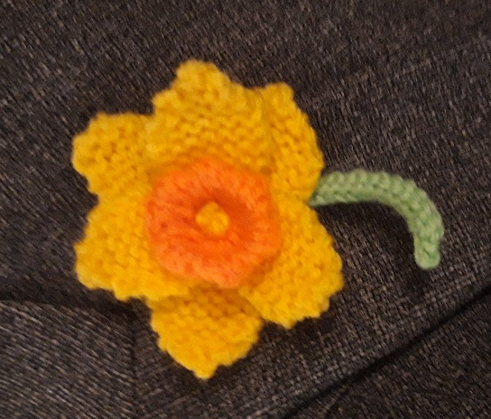

You will need:

A small amount of yellow double knitting yarn
A very small amount of green double knitting yarn
A pair of 3.25mm knitting needles
A pair of 4mm knitting needles
A darning needle

Instructions

For the centre trumpet:
Using 3.25 mm needs, cast on 14 stitches.
Row 1: Purl
Row 2: Knit
Repeat these two rows twice.
Change to 4mm needles for the picot edge
Row 7: Purl
Row 8: Knit 1, (slip 1, knit 1, pass the slip stitch over). Repeat the instructions in brackets to the last stitch. Knit 1. (8 stitches)
Row 9: Purl 2 stitches, (purl into the loop before the next stitch, purl 1) to the last stitch. Purl 1. (14 stitches)
Row 10: Knit.
Change back to 3.25mm needles.
Row 11: Purl
Row 12: Knit
Repeat these two rows
Row 15: Purl.
Break off the yarn, leaving about a 20cm length. Slip the 14 stitches onto this yarn (this is easier if you use the darning needle) but don’t draw up the stitches at this stage.
Using a different piece of yarn (the remaining yarn at the end of your cast on row is ideal), stitch the two short edges together.
Next, draw up the thread passed through the stitches and secure. This is the centre of your trumpet.
Fold the trumpet with the picot edge forming a slightly wavy edge..

For the petals:
Make six.
Using 3.25mm needles, cast on 7 stitches.
Rows 1 – 9: Knit
Row 10: Knit 2 stitches together, knit to end
Repeat this row 3 times (3 stitches).

Break off the yarn, leaving about a 15cm length. Slip the 3 stitches onto this yarn (this is easier if you use the darning needle) draw up and secure.

For the stem
Using the green yarn and 3.25mm needles, cast on 20 stitches.
Row 1: Knit
Row 2: Purl
Cast off.
The stem will curl inwards, showing the back of the stocking stitch. Sew the two long edges together and secure to form your stem.

To make up your daffodil
Stitch three petals to the back of the trumpet. Secure the yarn, but don’t cut off the loose ends at this stage.
Then stitch in the next three petals in the spaces between the first three.

Make the stamens for the centre by using two of the strands of loose yarn from the petals. Bring it though the centre of the trumpet using the darning needle. Before drawing the needle through fully, wrap the two strands of yarn twice round the needle before pulling through and retuning the needle to the back, creating a French knot. Do this three times.

Attach the stem to the back of your daffodil.

Sewing a medium sized safety pin to the back of your daffodil will make an attractive knitted daffodil to attach to a lapel.

Variations
In the illustration, orange yarn has been used to form a contrasting trumpet, but you can use the same colour for both.
You could make a narcissus with white petals and an orange centre – but as these have smaller trumpets, work two less rows both before and after the picot edge.

